Module 3.2: The Greenhouse Effect with PhET Simulations
Exploring Wave Interactions

Follow these steps with your team and use the PhET simulation to explore how light and infrared rays are impacted by greenhouse gas concentrations.

- Visit the PhET lab website and click on the “Waves” simulation. Before you start the simulation, make sure that you have “Cloud” and “Surface Temperature” are toggled on. Your screen should look like the following:

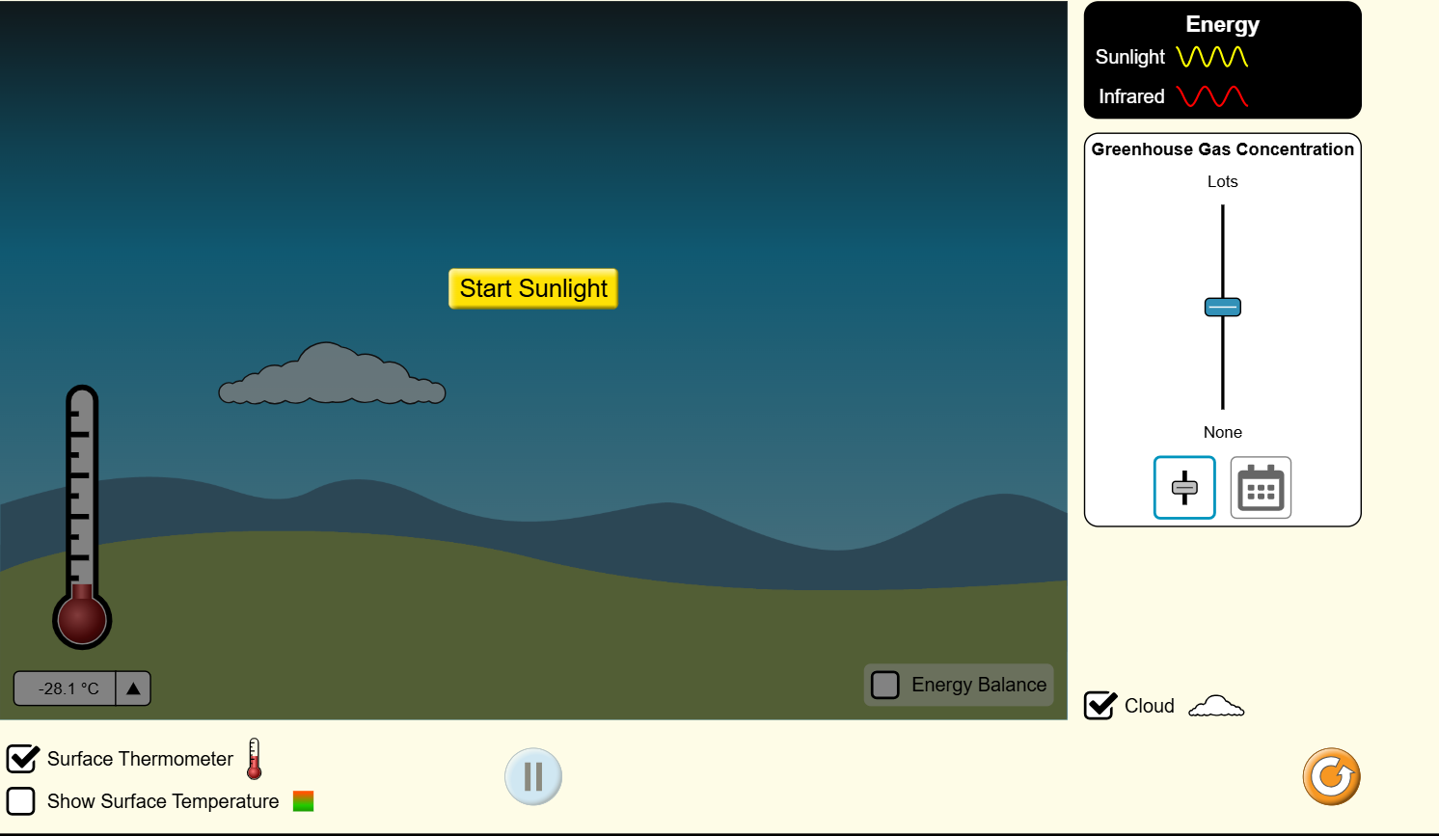

- Take a moment and observe the “Energy” key at the top right of the screen. During the simulation you will see these two energy waves that would normally be invisible.
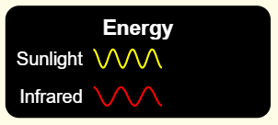

- When your team is ready, start the simulation by pressing the “Start Sunlight” button on your screen and take 30 seconds to observe what is happening on the simulation.
  - What did you and your team observe?
  - How are energy waves interacting with the system?

- With your simulation still running, locate the “Greenhouse Gas Concentration” bar. It will automatically be set to the center.

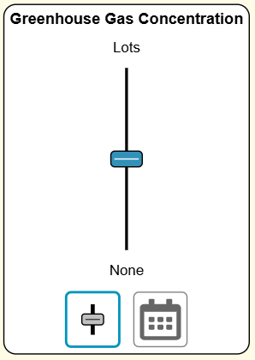

- Take a moment to manipulate the simulation by changing the “Greenhouse Gas Concentration” to a higher and lower amount and observe what happens in your system.
  - How did your system change as you decreased the greenhouse gas concentration in your simulation? Why do you think this happened?
  - How did your system change as you increased the greenhouse gas concentration in your simulation? Why do you think this happened?

Module 3.2: The Greenhouse Effect with PhET Simulations
Exploring Scenarios
Now that your team has explored wave interactions on the system, take a moment to explore how the levels of greenhouse gas concentration have changed throughout the years.

- Under the “Greenhouse Gas Concentration” box, click on the calendar icon to switch the view to include different scenarios. Your icon will change to look like the following:

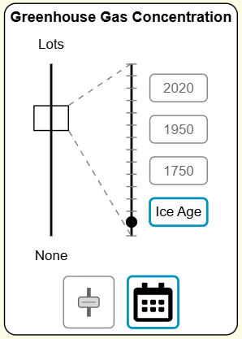

When you click on the calendar icon, you will notice that your system has changed as well.

- Next you will explore how greenhouse gas concentration has changed at different time periods and see how it has affected your system. To begin, click on “Ice Age” first and make initial observations on the greenhouse gas concentration and the surface temperature.
  - How would you describe the system?
  - How are energy waves interacting with the system? What impact are they having?

- After you’ve made your observations for “Ice Age” click on the next time period, “1750”. With your group, answer the following questions:
  - How has your system changed from the previous time period? What is the same? What is different?
  - How would you describe the greenhouse gas concentration during this time period? What is contributing to this concentration?
  - How has your surface temperature changed between the two time periods?

- Once you have made observations on the “1750” time period, repeat the process above and make observations for the “1950” and “2020” time periods.

- Once you have observed all time periods, take a moment to answer the following with your group.
  - How has the greenhouse gas concentration changed throughout the time periods?
  - What do you think is contributing to the change of greenhouse gases?
  - What impact have these greenhouse gases had on Earth?
  - What do you predict will happen to Earth’s surface temperature if these greenhouse gases continue to rise?

